yum install docker -y

systemctl enable docker && systemctl start docker

cat <<EOF > /etc/yum.repos.d/kubernetes.repo

[kubernetes]

name=Kubernetes

baseurl=https://packages.cloud.google.com/yum/repos/kubernetes-el7-x86_64

enabled=1

gpgcheck=1

repo_gpgcheck=1

gpgkey=https://packages.cloud.google.com/yum/doc/yum-key.gpg https://packages.cloud.google.com/yum/doc/rpm-package-key.gpg

EOF

cat /etc/yum.repos.d/kubernetes.repo

setenforce 0

yum install -y kubelet kubeadm kubectl

**sudo yum install ebtables ethtool**

sudo systemctl enable kubelet && systemctl start kubelet

sudo systemctl disable firewalld && systemctl stop firewalld

kubeadm join --token ba0689.104b8534bac9ff71 10.128.0.5:6443 --discovery-token-ca-cert-hash sha256:7d56e6ca5462e5613a95db86165799cd6f971c3a8e5cf4d4e2db8fdb51a3f48c --skip-preflight-checks

Notes

kubeadm] WARNING: kubeadm is in beta, please do not use it for production clusters.

[preflight] Running pre-flight checks

[preflight] Some fatal errors occurred:

/var/lib/kubelet is not empty

[preflight] If you know what you are doing, you can skip pre-flight checks with `--skip-preflight-checks`

[root@kube-node1 anil_bidari82]# kubeadm join --token ba0689.104b8534bac9ff71 10.128.0.5:6443 --discovery-token-ca-cert-hash sha256:7d56e6ca5462e5613a95db86165799cd6f971c3a8e5cf4d4e2db8fdb51a3f48c --skip-preflight-checks

[kubeadm] WARNING: kubeadm is in beta, please do not use it for production clusters.

[preflight] Skipping pre-flight checks

[discovery] Trying to connect to API Server "10.128.0.5:6443"

[discovery] Created cluster-info discovery client, requesting info from "https://10.128.0.5:6443"

[discovery] Requesting info from "https://10.128.0.5:6443" again to validate TLS against the pinned public key

[discovery] Cluster info signature and contents are valid and TLS certificate validates against pinned roots, will use API Server "10.128.0.5:6443"

[discovery] Successfully established connection with API Server "10.128.0.5:6443"

[bootstrap] Detected server version: v1.8.0

[bootstrap] The server supports the Certificates API (certificates.k8s.io/v1beta1)

Node join complete:

* Certificate signing request sent to master and response

received.

* Kubelet informed of new secure connection details.

Run 'kubectl get nodes' on the master to see this machine join.



docker ps

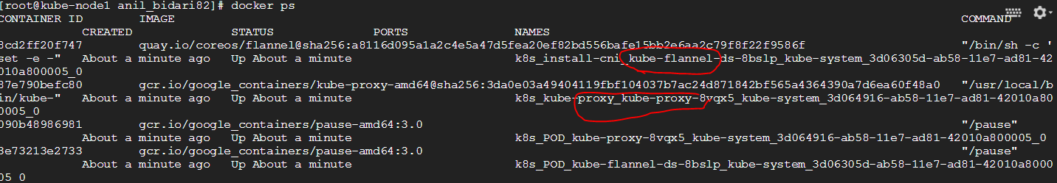

Goto your **master node**

Kubectl get nodes

